|  |
| --- |
|  |
| BIFROST AVS Vacuum tank MOTION SAT |
|  |

|  | Name | Role/Title |
| --- | --- | --- |
| Owner | Anders Sandström | Electronics Engineer Motion Control & Automation |
| Owner | Federico Rojas | Motion Control Engineer |
| Reviewer | Thomas Gahl | Group Leader Motion Control & Automation |
| Approver | Liam Whitelegg | Instrument Lead Engineer for BIFROST |

# Results

In general, the tests went well until the test measuring the total motion range. When approaching the upper hard limit, the tank collided with the center concrete block. Most tests were already done before the collision but some extra data was collected after in order to see if the collision had any impact on the motion performance of the movement. A comparison can be found in chapter 2.

## General inspection

* Vacuum equipment was found to be connected and prevented motion and had to be disconnected.
* Grounding of crate vs the vacuum tank assembly was measured to be OK.
* A small dent on the Posital encoder housing was identified, Figure 1.

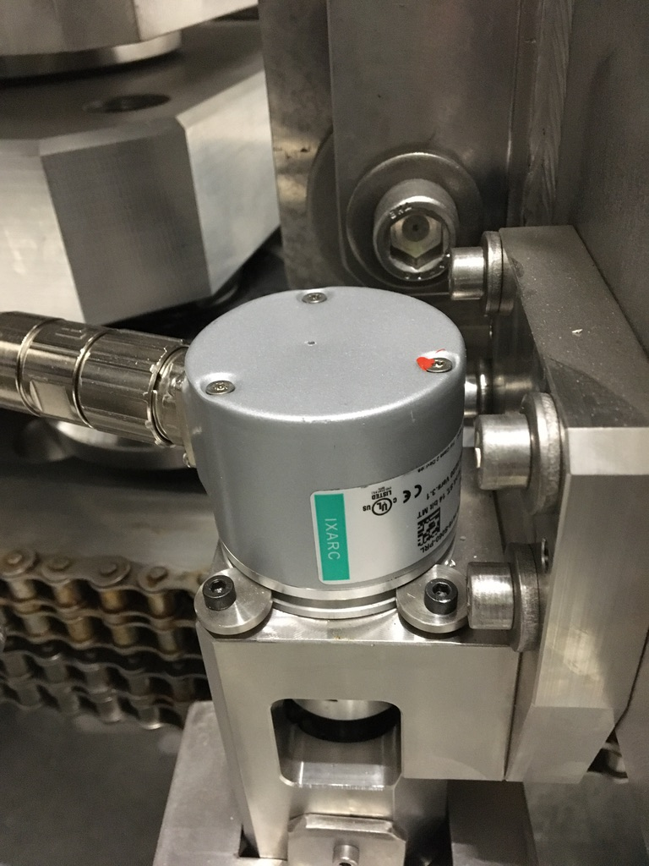

Figure 1: Posital encoder dent

## Initial motion test

### Switches

All switches except the anti-collision switch was found to be engaging properly. The anti-collision switch was therefore adjusted.

### Gear ratio

Basic gear ratios were calculated for both encoder and motor.

Gear ratio motor: 8,10165*10-5degtank/degmotor

Gear ratio encoder: 4.43610-5degtank/countsencoder

These gear ratios were used to generate setpoints for the further tests.

For analysis of the data, gear ratios calculated from the accuracy test are used.

### Backlash

A simple backlash tests was performed at approx. -10deg (only at one position). The test measures only the backlash between encoder and motor shaft.

Figure 2 shows a graph for the backlash test in forward direction and Figure 3 shows the backlash test in backward direction.

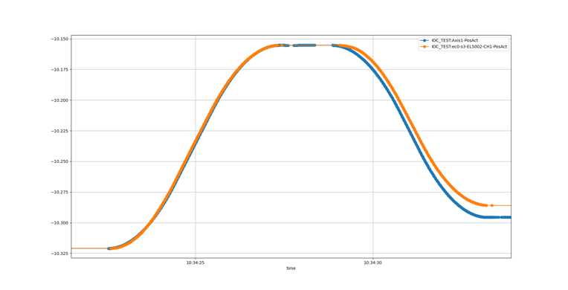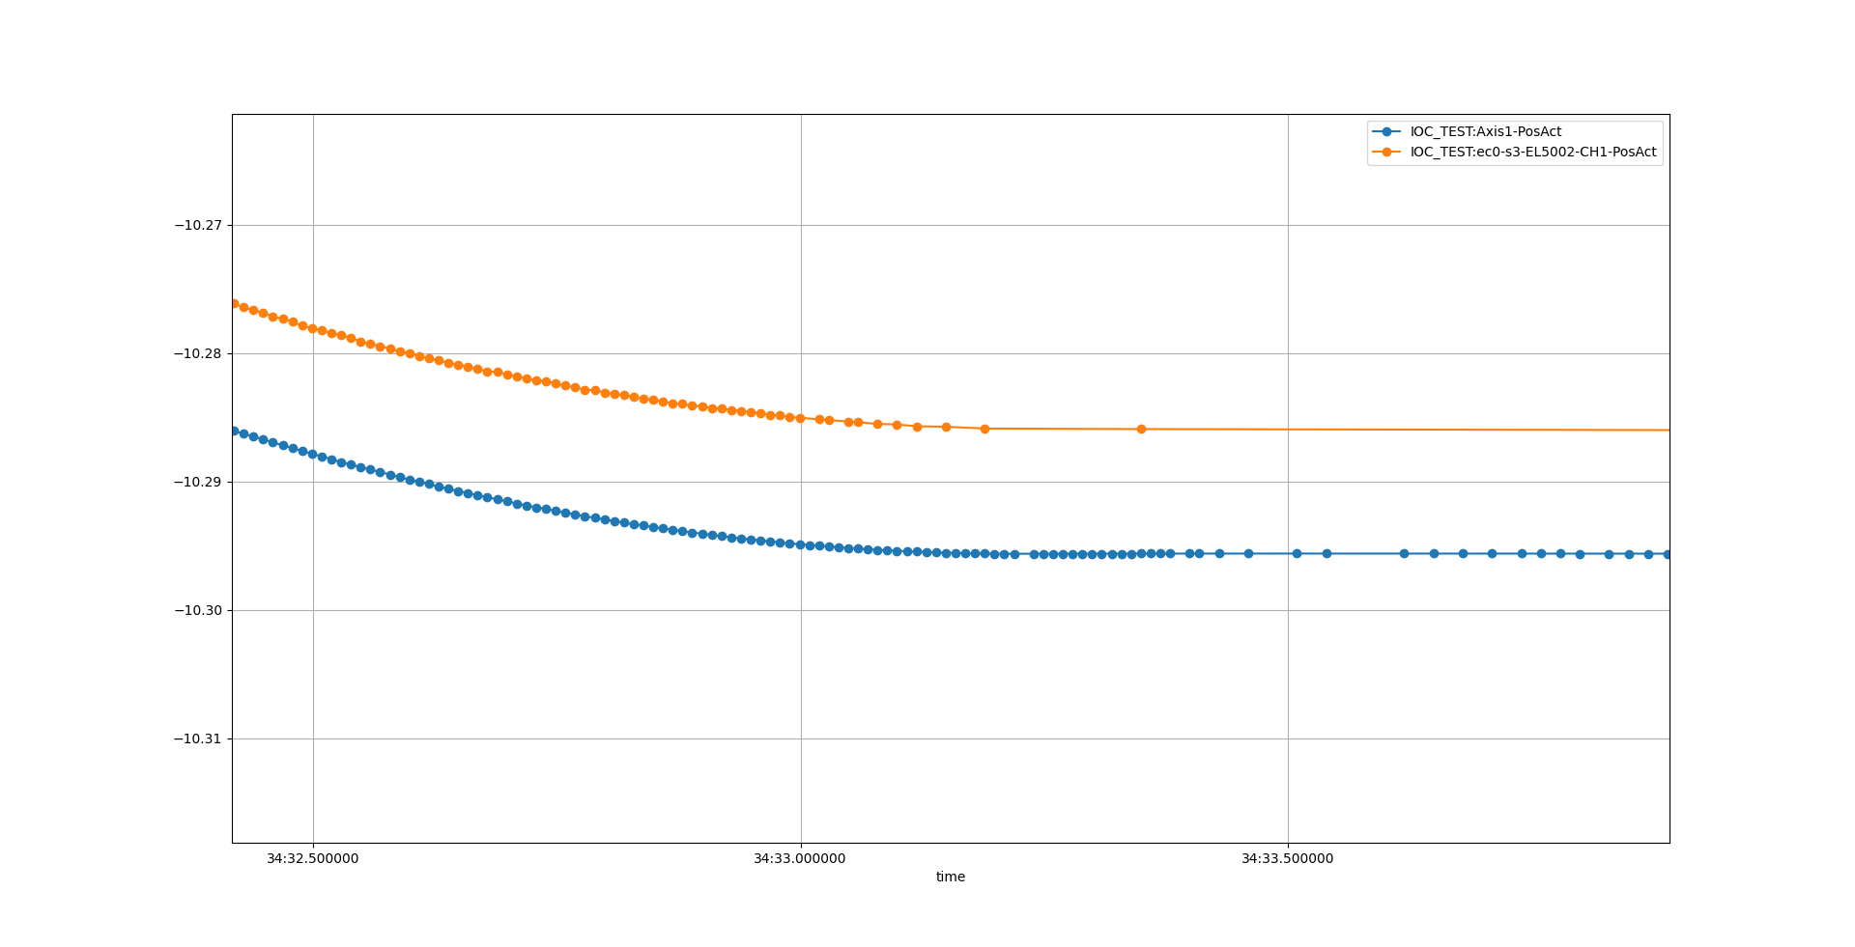

Tank angle

Time

o Motor open loop position

o Encoder position

Figure 2: Backlash test in backward direction

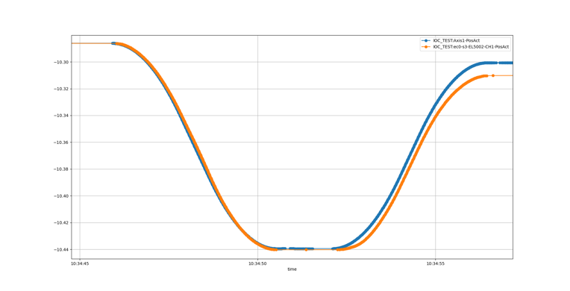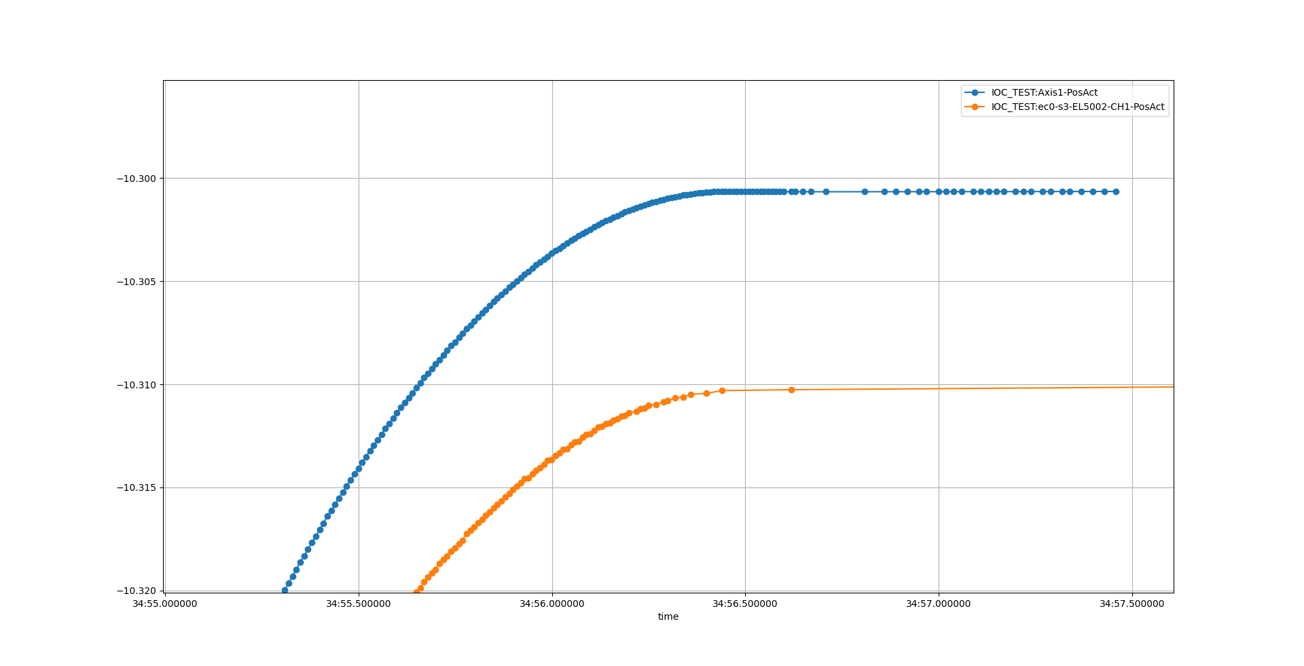

o Motor open loop position

o Encoder position

Tank angle

Time

Figure 3: Backlash test in forward direction

Both tests indicate a backlash of 0.01deg between motor and encoder.

## Motion range and switch performance

### Motion range

The low hard stop was measured to be at approx. -10.98deg. and the upper hard stop could not be reached.

When approaching the upper hard limit, the tank collided with the center concrete block, Figure 4.

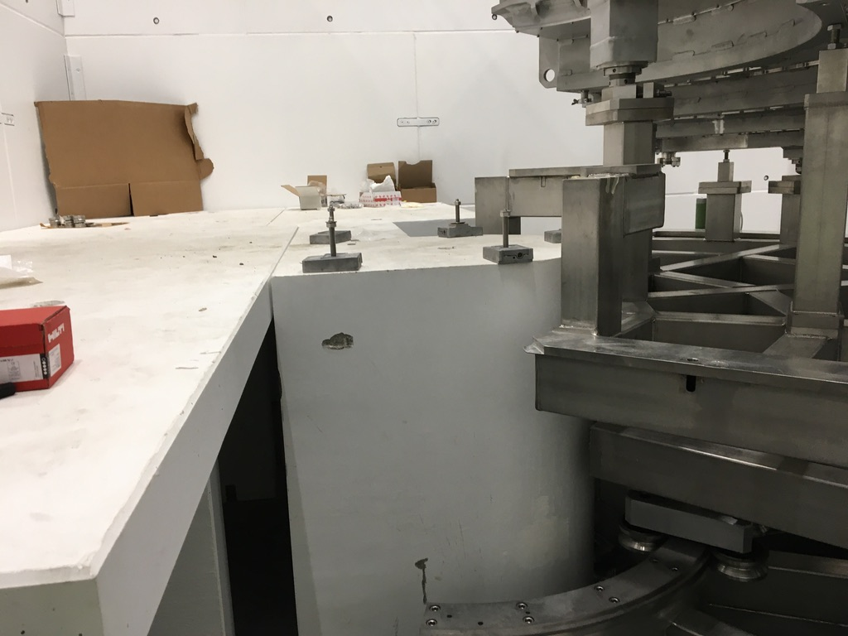

Figure 4: Collision with center concrete block.

After the collision, the CAD drawings were checked and there it was clear that it would not be possible to reach the hard stop, Figure 5, unfortunately this was not realized before it happened.



Figure 5: CAD drawing of tank in hard stop position (from above)

As can be seen in the cad drawing, the edge of the upper tank frame collides with the concrete block and after analysis it was concluded that both the concrete block and the tank frame was displaced.

An analysis of the motion performance differences before and after the collision can be found in chapter 2.

### Switch performance

Data acquired in the switch performance test are presented in Appendix A Switch performance.

The data switch position data is based on encoder position that have been calibrated with laser tracker measurements from the accuracy tests described in chapter 1.5.

The data is summarized in Table 1.

Table 1: Switch performance

|  |  |  |  |  |
| --- | --- | --- | --- | --- |
|  | **Engage** |  | **Disengage** |  |
| **Switch** | **Position [deg]** | **Range [deg]** | **Position [deg]** | **Range [deg]** |
| Low kill | -4,606 | 0,001 | -4,574 | 0,000 |
| Low limit | -4,281 | 0,001 | -4,253 | 0,001 |
| Anti-collision | 32,863 | 0,000 | 32,831 | 0,000 |
| High limit | 44,965 | 0,000 | 44,923 | 0,000 |
| High kill | 45,350 | 0,000 | 45,321 | 0,000 |

## High speed test

No problem was encountered when running in 0.1 deg/s. The whole stroke was measured and the encoder and motor position follow like expected, see Figure 6.

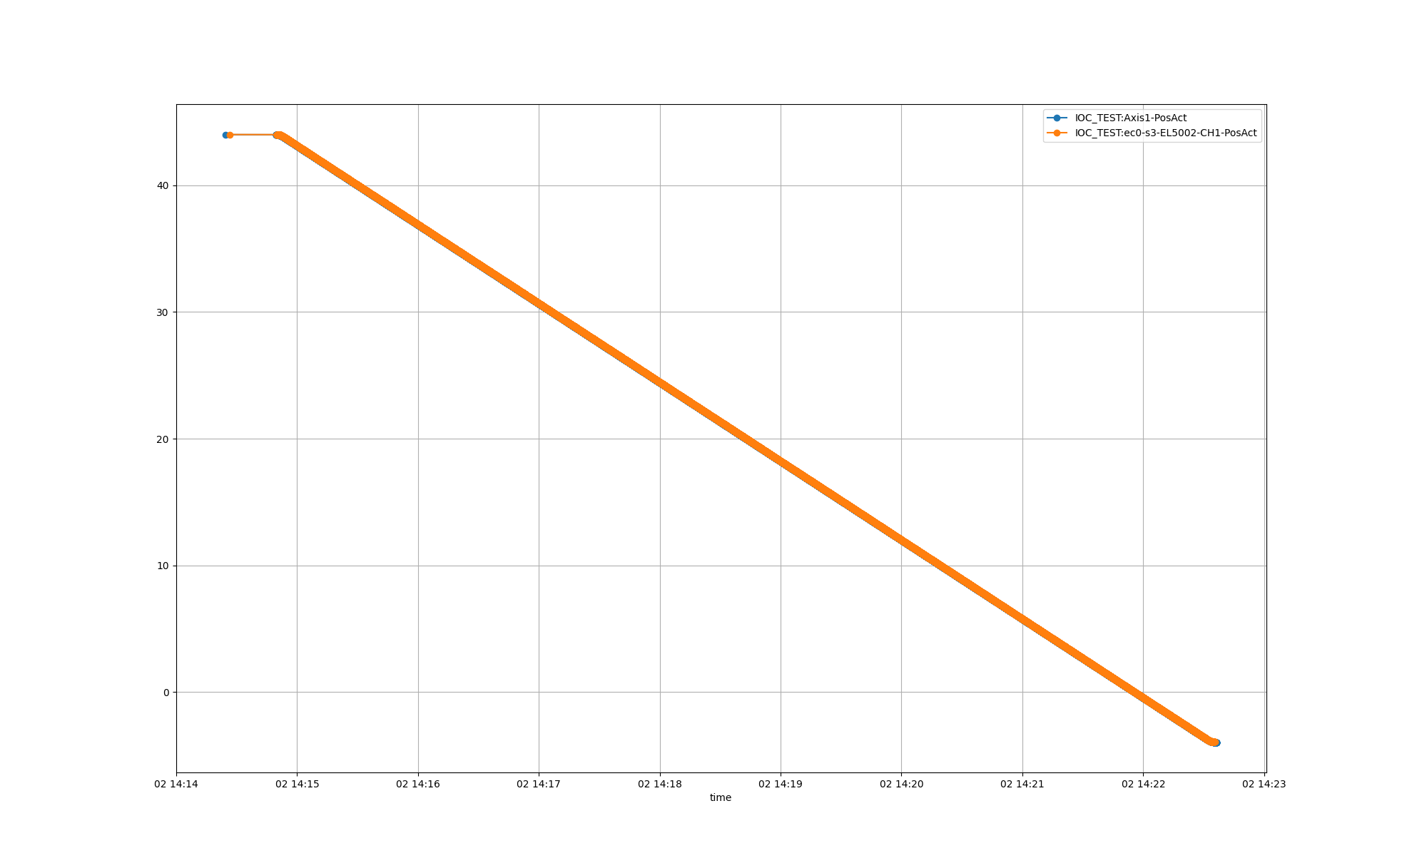

Time

o Motor open loop position

o Encoder position

Tank angle

Figure 6: High speed test over entire stroke (backward direction)

By removing the linear component of the encoder position data, the error of encoder position versus the motor position can be analyzed, see Figure 7.

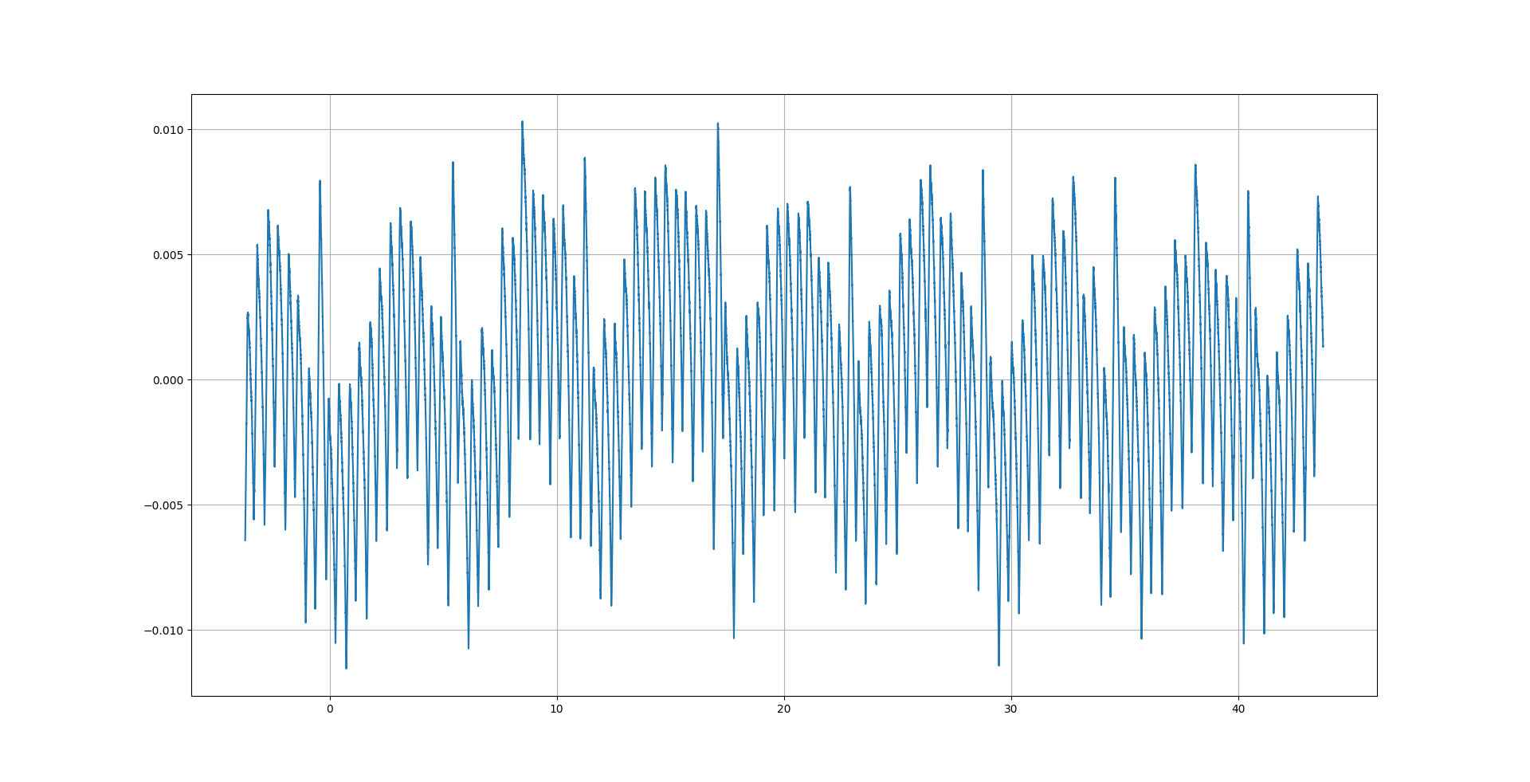

Tank angle

Figure 7: Encoder error vs tank angle (without backlash)

The data shows a repeated oscillation, each 5-6 degrees, in the error between the motor position and encoder position. Also, a shorter wavelength disturbance can be identified, Figure 8. The source of these errors can probably be found in the mechanical design, like frame design and motion system (gears and chains).

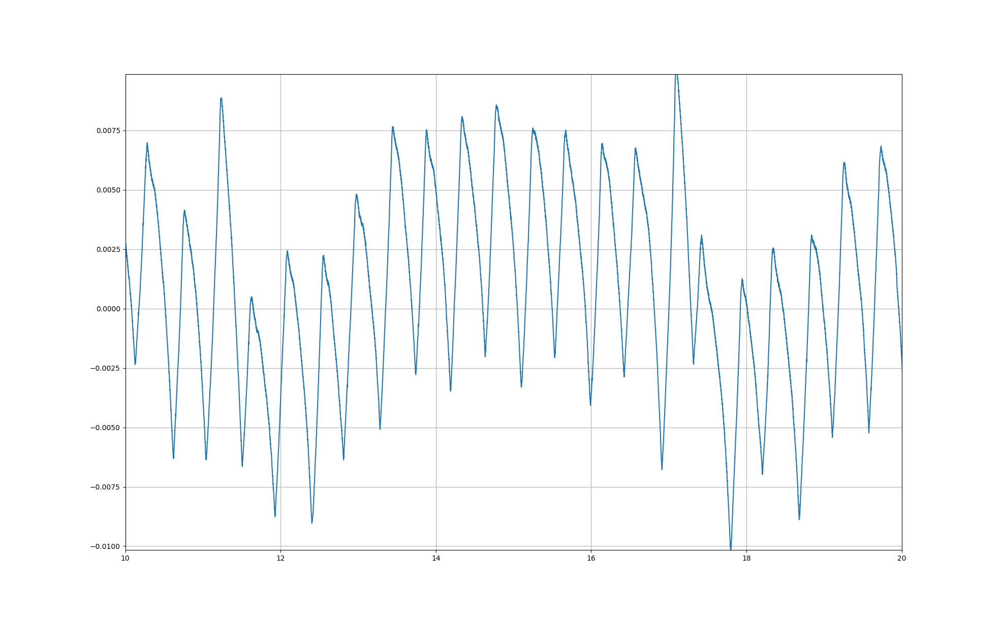

Figure 8: Encoder error vs tank angle, zoom 10..20 deg (without backlash)

Both these disturbances will lead to a maximum error over the stroke of +-0.01 degrees between the motor position and the encoder position (excluding backlash).

## Accuracy

Table 2, shows the data collected during the accuracy test.

Table 2: Accuracy test data

|  |  |  |  |  |  |
| --- | --- | --- | --- | --- | --- |
| **Position** | **Laser tracker position [deg]** | **Open loop position [deg]** | **Open loop diff abs [deg]** | **Encoder [deg]** | **Encoder Diff abs [deg]** |
| hardstop low | -10,98 | -10,97821038 | 0,001789625 | -10,97441724 | 0,005582764 |
| -5 | -5,0177 | -5,0097 | 0,0080 | -5,0102 | 0,0075 |
| 0 | 0,0192 | -0,0081 | 0,0273 | -0,0117 | 0,0309 |
| 5 | 4,9862 | 4,9934 | 0,0072 | 4,9956 | 0,0094 |
| 10 | 9,9888 | 9,9949 | 0,0061 | 9,9986 | 0,0098 |
| 15 | 14,9897 | 14,9964 | 0,0067 | 15,0016 | 0,0119 |
| 20 | 19,9951 | 19,9980 | 0,0029 | 19,9979 | 0,0028 |
| 25 | 24,9998 | 24,9995 | 0,0003 | 24,9971 | 0,0027 |
| 30 | 29,9965 | 30,0010 | 0,0045 | 29,9951 | 0,0014 |
| 35 | 35,0005 | 35,0025 | 0,0020 | 34,9974 | 0,0031 |
| 40 | 40,0095 | 40,0041 | 0,0054 | 40,0049 | 0,0046 |
| 45 | 45,0127 | 45,0056 | 0,0071 | 45,0114 | 0,0013 |
| hardstop high | 48,5000 |  |  |  |  |

From the data the optimal gear ratio and accuracy can be calculated, see Table 3.

Table 3: Accuracy

|  |  |  |  |
| --- | --- | --- | --- |
| **Source** | **Gear ratio []** | **Offset [deg]** | **Accuracy [deg]** |
| **Open loop position** | 8,10412E-05 degtank/degmotor | -0,0081 | 0,0273 |
| **Encoder position** | -4,45114E-05 degtank/encoder count | 30,7267 | 0,0309 |

Note: Since only one data point per target position was measured, the maximum deviation from target position is considered to be the accuracy.

In Table 2, the value at 0 degrees is clearly standing out with high deviation. If the values at zero is considered as an outlier and thereby excluded the updated accuracy values can be found in Table 4 and Table 5.

Table 4: Accuracy test data with position zero excluded

|  |  |  |  |  |  |
| --- | --- | --- | --- | --- | --- |
| **Position** | **Laser tracker [deg]** | **Open loop position [deg]** | **Open loop diff abs [deg]** | **Encoder [deg]** | **Encoder Diff abs [deg]** |
| hardstop low |  |  |  |  |  |
| -5 | -5,0177 | -5,0194 | 0,0017 | -5,02125 | 0,0036 |
| 0 | Excluded | Excluded | Excluded | Excluded | Excluded |
| 5 | 4,9862 | 4,9862 | 0,0000 | 4,9875 | 0,0013 |
| 10 | 9,9888 | 9,9890 | 0,0002 | 9,9920 | 0,0032 |
| 15 | 14,9897 | 14,9919 | 0,0022 | 14,9964 | 0,0067 |
| 20 | 19,9951 | 19,9947 | 0,0004 | 19,9942 | 0,0009 |
| 25 | 24,9998 | 24,9975 | 0,0023 | 24,9949 | 0,0049 |
| 30 | 29,9965 | 30,0004 | 0,0039 | 29,9944 | 0,0021 |
| 35 | 35,0005 | 35,0032 | 0,0027 | 34,9981 | 0,0024 |
| 40 | 40,0095 | 40,0060 | 0,0035 | 40,0071 | 0,0024 |
| 45 | 45,0127 | 45,0089 | 0,0038 | 45,0150 | 0,0023 |
| hardstop high | 48,5000 |  |  |  |  |

Table 5: Accuracy with position 0 excluded

|  |  |  |  |
| --- | --- | --- | --- |
| **Source** | **Gear ratio** | **Offset [deg]** | **Accuracy [deg]** |
| **Open loop position** | 8,1062E-05 | -0,0166 | 0,0039 |
| **Encoder position** | -4,4525E-05 | 30,7262 | 0,0067 |

## Bidirectional repeatability

Data acquired during the repeatability test are listed in Appendix B: Repeatability data.

Based on these data sets the repeatability can be calculated to be 0.010 deg.

# Differences before and after collision

In order to judge if the collision have impacted the performance of the motion system some comparisons can be made by looking at data collected before and after. Unfortunately, only a few comparable datasets have been identified but in total three comparisons can be made based on the recorded data:

1. Backlash
2. Encoder error (vs linear open loop counter)
3. Accuracy and gear ratio

## Backlash

From the data acquired during the high-speed tests also backlash in one direction can be checked. Figure 9 shows motor open loop counter and encoder position during the acceleration phase.

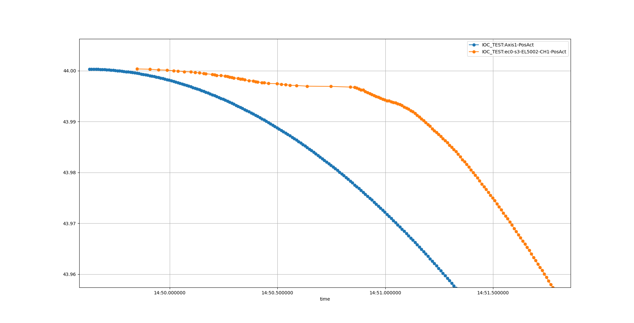

Time

Tank angle

o Motor open loop position

o Encoder position

Figure 9: Backlash after collision

For this move the backlash seems to be approx. 0.02deg compared to 0.01deg before. Another thing worth noting is the behavior of the encoder position curve where the value seems to update unpredictable in the acceleration phase

Note: Before the collision, no data was recorded at this tank angle. Therefore, it’s hard to judge if the increase in backlash is related to the collision.

## Motor position vs encoder position

Data for open loop counter position and encoder position was acquired for angles between 9 and 23 degrees both before and after collision. Unfortunately, the velocity was different at the two tests:

* before collision 688degmotor/s
* after collision 1280degmotor/s

Figure 10 shows the deviation of the encoder position from the motor open loop position at angles between 9 to 23 degrees (at a velocity of 688degmotor/s). Figure 11 shows the same data but acquired after the collision but at a higher velocity (1280degmotor/s). In both graphs the backlash is not shown.

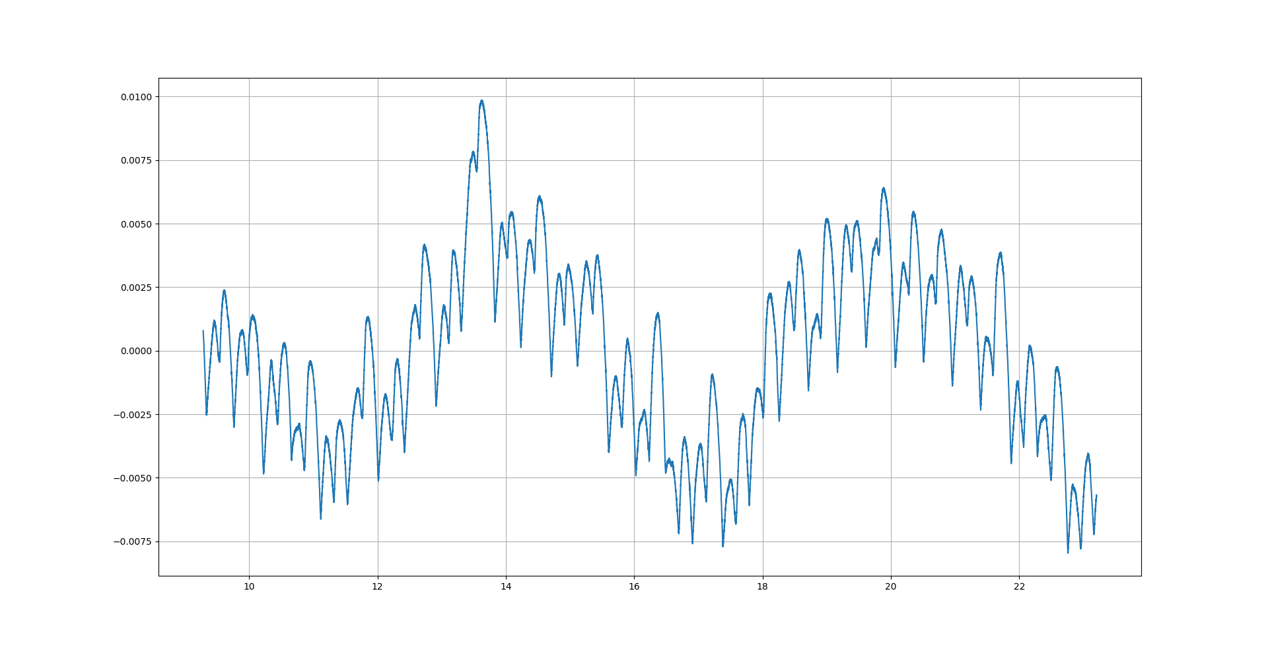

Figure 10: Before collision: Encoder position error (without backlash) at 688degmotor/s

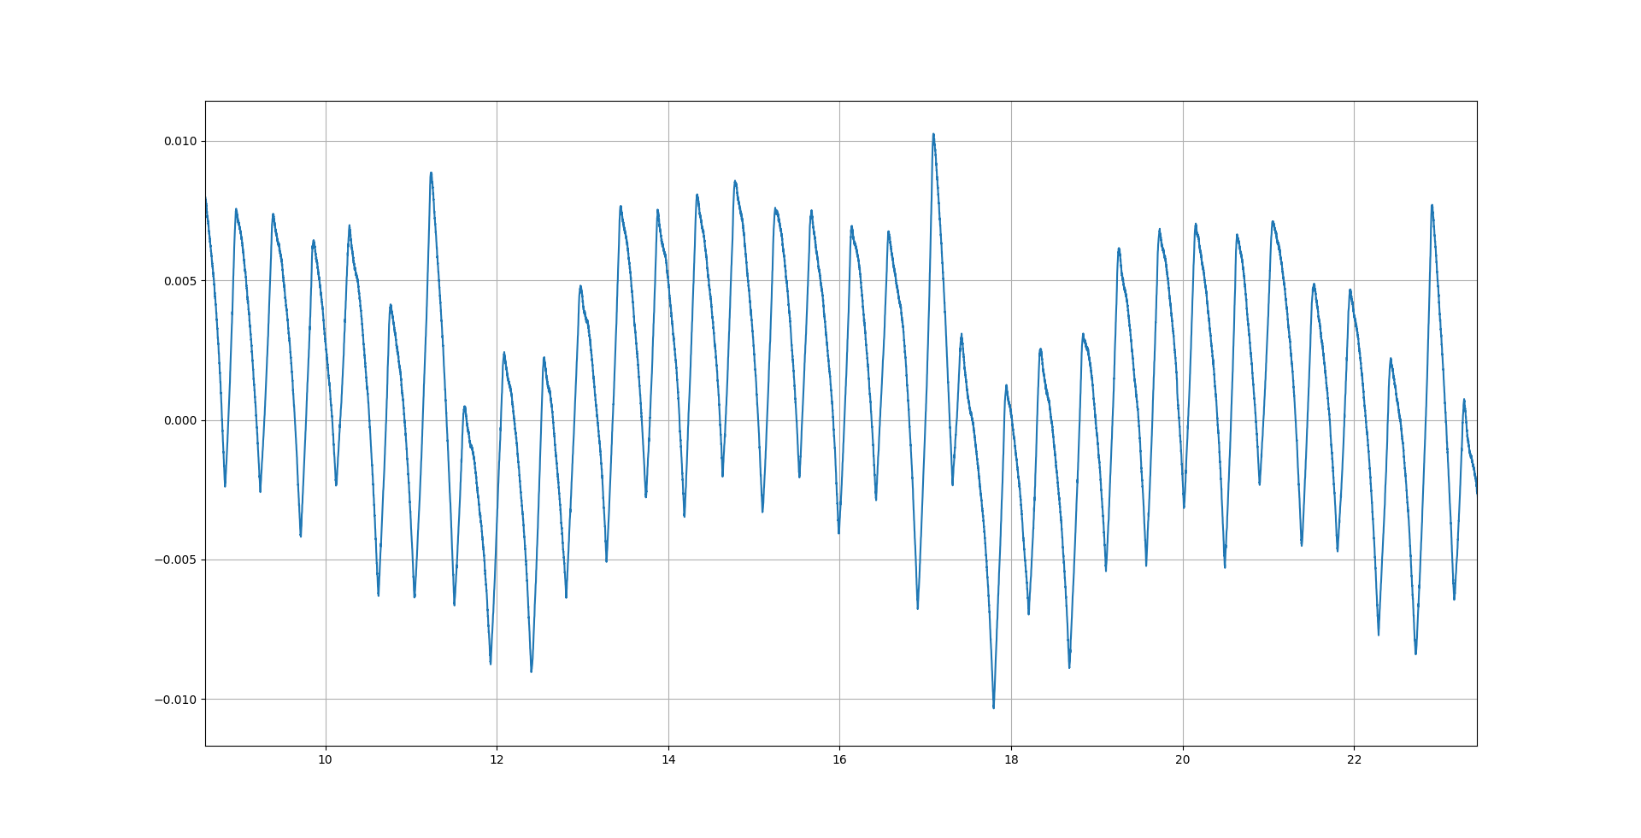

Figure 11: After collision: Encoder position error (without backlash) at 1280degmotor/s

The same cyclic error with a frequency of approx. 6 degrees and an amplitude 0.01deg can be identified in both graphs. However, the amplitude of the lower wavelength error has increased after the collision.

## Accuracy and gear ratio

A reduced accuracy test was performed after the collision. In this test, some of the measurement positions were excluded, Table 6. The values for position 0 is excluded in the comparison since data for this position was considered a outlier in the dataset acquired before collision.

Table 6: After collision: Accuracy measurements

|  |  |  |  |  |  |
| --- | --- | --- | --- | --- | --- |
| **Position** | **Laser tracker [deg]** | **Open loop position [deg]** | **Open loop diff abs [deg]** | **Posital Encoder [deg]** | **Posital Diff abs [deg]** |
| hardstop low | 10.98 |  |  |  |  |
| -5 | -5,0017 | -5,0164 | 0,0147 | -5,0039 | 0,0022 |
| 0 | 0,0000 | -0,0165 | excluded | 0,0013 | excluded |
| 5 | 4,9725 | 4,9834 | 0,0109 | 4,9737 | 0,0012 |
| 10 | 9,9755 | 9,9833 | 0,0078 | 9,9784 | 0,0029 |
| 15 |  |  |  |  |  |
| 20 |  |  |  |  |  |
| 25 |  |  |  |  |  |
| 30 |  |  |  |  |  |
| 35 | 34,9801 | 34,9826 | 0,0025 | 34,9763 | 0,0038 |
| 40 |  |  |  |  |  |
| 45 | 44,9890 | 44,9824 | 0,0066 | 44,9908 | 0,0018 |
| hardstop high |  |  |  |  |  |

The calculated accuracy values based on these data are shown in Table 7. These values can be compared with the accuracies calculated based on the data from the same positions before collision, Table 8. Note that the data for position 0 have also been excluded from the data taken from before collision since this data set seems to be an outlier.

Table 7: After collision: Accuracy and gear ratio

|  |  |  |  |
| --- | --- | --- | --- |
| **Source** | **Gear ratio** | **Offset [deg]** | **Accuracy [deg]** |
| **Open loop position** | 8,10623E-05 | 0,0001 | 0,0147 |
| **Encoder position** | -4,45245E-05 | 30,7262 | 0,0038 |

Table 8: Before collision: Accuracy measurements (same points as after collision but excluding 0 position)

|  |  |  |  |  |  |
| --- | --- | --- | --- | --- | --- |
| **Position** | **Laser tracker [deg]** | **Open loop position [deg]** | **Open loop diff abs [deg]** | **Posital Encoder [deg]** | **Posital Diff abs [deg]** |
| hardstop low |  |  |  |  |  |
| -5 | -5,0177 | -5,0188 | 0,0011 | -5,0202 | 0,0025 |
|  | Excluded | Excluded |  | Excluded |  |
| 5 | 4,9862 | 4,9866 | 0,0004 | 4,9878 | 0,0016 |
| 10 | 9,9888 | 9,9893 | 0,0005 | 9,9919 | 0,0031 |
|  |  |  |  |  |  |
|  |  |  |  |  |  |
|  |  |  |  |  |  |
|  |  |  |  |  |  |
| 35 | 35,0005 | 35,0027 | 0,0022 | 34,9961 | 0,0044 |
|  |  |  |  |  |  |
| 45 | 45,0127 | 45,0080 | 0,0047 | 45,0123 | 0,0004 |
| hardstop high |  |  |  |  |  |

Table 9: Before collision: Accuracy and gear ratio

|  |  |  |  |
| --- | --- | --- | --- |
| **Source** | **Gear ratio** | **Offset [deg]** | **Accuracy [deg]** |
| **Open loop position** | 8,10599E-05 | -0,0161 | 0,0047 |
| **Encoder position** | 4,45212E-05 | 30,7245 | 0,0044 |

The accuracy of the motor open loop position has degraded from 0.0047deg to 0.0147 deg. The accuracy of the Posital encoder have not changed significantly, 0.0044 deg before collision compared to 0.0038 after collision.

Worth noting is that the optimal gear ratio has changed slightly mainly for the motor shaft.

# CONCLUSIONS

Results from the tests are summarized in the below tables. Table 10 shows general results and Table 11 and Table 12 shows motion performance before and after collision.

Table 10: General results

|  |  |  |  |  |
| --- | --- | --- | --- | --- |
| **Test:** | **Description:** | **Value** | **Status:** | **Comment:** |
| **1** | **General Inspection** |  |  |  |
| **1.1** | **Mechanical** |  |  |  |
| **1.1.1** | **Observations** |  | OK | Dent on Posital encoder housing. Encoder was concluded to work correct. |
| **1.2** | **Electrical** |  |  |  |
| **1.2.1** | **Observations** |  |  |  |
| **1.2.2** | **Grounding** |  | OK |  |
| **1.2.3** | **Motor Phase A** |  | OK |  |
| **1.2.4** | **Motor Phase B** |  | OK |  |
| **1.2.5** | **Low Limit Switch** |  | OK |  |
| **1.2.6** | **High Limit Switch** |  | OK |  |
| **1.2.7** | **Anti-Collision Switch** |  | OK | Needed adjustment |
| **1.2.8** | **Low Kill Switch** |  | OK |  |
| **1.2.8** | **High Kill Switch** |  | OK |  |

Table 11: Results from data acquired before collision

|  |  |  |  |  |
| --- | --- | --- | --- | --- |
| **2** | **Initial Motion Test** |  |  |  |
| **2.1** | **Gera ratio posital encoder []** | -4,4525E-05 | OK |  |
| **2.1** | **Gera ratio open loop []** | 8,1062E-05 | OK |  |
| **2.1** | **Backlash [deg]** | 0,01 | OK | Based on one measurement at -10 deg |
|  | **Motion Performance** |  |  |  |
| **3** | **Range and switch performance** |  |  |  |
| **3.1** | **Range (hard stop to hardstop)** |  | Not ok | Could not reach upper hard limit |
| **3.2** | **Low Kill Engage [deg]** | -4,61 | OK |  |
| **3.2** | **Low Kill Disengage [deg]** | -4,57 | OK |  |
| **3.3** | **Low Limit Engage [deg]** | -4,28 | OK |  |
| **3.3** | **Low Limit Disengage [deg]** | -4,25 | OK |  |
| **3.4** | **Anti -Collision Engage [deg]** | 32,86 | OK |  |
| **3.4** | **Anti -Collision Disengage [deg]** | 32,83 | OK |  |
| **3.5** | **High Limit Engage [deg]** | 44,97 | OK |  |
| **3.5** | **High Limit Disengage [deg]** | 44,92 | OK |  |
| **3.6** | **High Kill Engage [deg]** | 45,35 | OK |  |
| **3.6** | **High Kill Disengage [deg]** | 45,32 | OK |  |
| **5** | **Accuracy open loop [deg]** | 0,0039 | OK | Zero position was treated as an outlier and therefore excluded. |
| **5** | **Accuracy Posital encoder [deg]** | 0,0067 | OK | Zero position was treated as an outlier and therefore excluded. If analysis is made on only the data points collected after collision the accuracy would be 0,0044 |
| **6** | **Bidirectional repeatability [deg]** | 0,0088 | OK | Zero position was treated as an outlier and therefore excluded. |

Table 12: Results from after collision

|  |  |  |  |  |
| --- | --- | --- | --- | --- |
| **2** | **Initial Motion Test** |  |  |  |
| **2.1** | **Gera ratio posital encoder []** | -4,4525E-05 | OK | Seems to have changed slightly |
| **2.1** | **Gera ratio open loop []** | 8,1062E-05 | OK |  |
| **2.1** | **Backlash [deg]** | 0,02 | Check | Based on high speed test at 45 deg. Need more data to conclude, see chapter 2 for detailed comparison. |
|  | **Motion Performance** |  |  |  |
| **4** | **High speed test** |  | OK |  |
| **5.1** | **Accuracy open loop [deg]** | 0,0147 | Check | Open loop accuracy seems to be worse after collision. But data is based on only a few measurements, see chapter 2 for detailed comparison |
| **5.2** | **Accuracy Posital encoder[deg]** | 0,0038 | OK | Even better than before collision but fewer measurements, see chapter 2 for detailed comparison. |
| **6** | **Bidirectional repeatability [deg]** |  | Check | Not measured after collision. |

In general, the equipment fulfills all of the requirements. However, based on the above analysis it would be good to make a few further tests to at least verify some of the parameters again after collision. One alternative would be to use the Posital encoder as a reference instead of the Laser tracker since it has shown to correspond well to the laser tracker both before and after the collision. Using the Posital encoder as reference system would allow a simpler test setup and faster tests.

# references

1. EtherCAT organization, <https://www.ethercat.org>
2. ecmc, open source motion control, <https://accelconf.web.cern.ch/icalepcs2017/talks/mocpl05_talk.pdf>

Document Revision history

| Revision | Reason for and description of change | Author | Date |
| --- | --- | --- | --- |
| 1 | First issue | Anders Sandström | 2020-12-17 |
|  |  |  |  |
|  |  |  |  |

# Appendix A Switch performance

|  |  |  |  |  |
| --- | --- | --- | --- | --- |
| Low Kill Switch | Posital encoder |  |  |  |
| L1 | Engage | Disengage | Engage range | Disengage Range |
| 1 | -4,606081958 | -4,573677657 | 0,000712182 | 0,00031158 |
| 2 | -4,605681355 | -4,573855703 |  |  |
| 3 | -4,605859401 | -4,573855703 |  |  |
| 4 | -4,606393537 | -4,573811191 |  |  |
| 5 | -4,605903912 | -4,573989237 |  |  |
|  |  |  |  |  |
|  |  |  |  |  |
| Low Limit Switch | Posital encoder |  |  |  |
| L2 | Engage | Disengage | Engage range | Disengage Range |
| 1 | -4,280436542 | -4,252973007 | 0,000845716 | 0,000756694 |
| 2 | -4,281282258 | -4,253329098 |  |  |
| 3 | -4,280970678 | -4,253729701 |  |  |
| 4 | -4,281104213 | -4,253551655 |  |  |
| 5 | -4,281104213 | -4,253729701 |  |  |
|  |  |  |  |  |
|  |  |  |  |  |
| Anticollision Switch | Posital encoder |  |  |  |
| L3 | Engage | Disengage | Engage range | Disengage Range |
| 1 | 32,86241426 | 32,83125629 | 0,00031158 | 0,000356091 |
| 2 | 32,86272584 | 32,8309002 |  |  |
| 3 | 32,86259231 | 32,83103373 |  |  |
| 4 | 32,8625478 | 32,83107824 |  |  |
| 5 | 32,86259231 | 32,83103373 |  |  |
|  |  |  |  |  |
|  |  |  |  |  |
| High Limit Switch | Posital encoder |  |  |  |
| L4 | Engage | Disengage | Engage range | Disengage Range |
| 1 | 44,96484186 | 44,92268956 | 0,0004006 | 0,000400602 |
| 2 | 44,96519795 | 44,92264505 |  |  |
| 3 | 44,96484186 | 44,92228896 |  |  |
| 4 | 44,96524246 | 44,92251152 |  |  |
| 5 | 44,96488637 | 44,92251152 |  |  |
|  |  |  |  |  |
|  |  |  |  |  |
| Switch | Posital encoder |  |  |  |
| L5 | Engage | Disengage | Engage range | Disengage Range |
| 1 | 45,34999902 | 45,32097758 | 0,00031158 | 0,00035609 |
| 2 | 45,34982098 | 45,32133367 |  |  |
| 3 | 45,34999902 | 45,32128916 |  |  |
| 4 | 45,34995451 | 45,32097758 |  |  |
| 5 | 45,35013256 | 45,32111112 |  |  |

# Appendix B: Repeatability data

|  |  |  |  |
| --- | --- | --- | --- |
| **Position** | **-5deg** | **from below** |  |
| Test | Laser Scanner | Open loop counter | Posital encoder |
| 1 | -5,0168 | -5,009677375 | -5,01002292 |
| 2 | -5,0185 | -5,009676806 | -5,01020097 |
| 3 | -5,0184 | -5,009677375 | -5,01042353 |
| 4 | -5,0197 | -5,009676806 | -5,01091315 |
| 5 | -5,0196 | -5,009677375 | -5,01055706 |
| 6 | -5,0196 | -5,009677375 | -5,01077962 |
| Range | 0,00290 | 0,00000057 | 0,00089 |
| STD | 0,001125463 | 2,94192E-07 | 0,0003386 |
| Repeatabilty | 0,00290 |  |  |
|  |  |  |  |
| **Position** | **-5deg** | **from above** |  |
| Test | Laser Scanner | Open loop counter | Posital encoder |
| 1 | -5,0073 | -5,00966996 | -4,9966695 |
| 2 | -5,0064 | -5,00966996 | -4,99707011 |
| 3 | -5,0065 | -5,00966996 | -4,99684755 |
| 4 | -5,006 | -5,00966996 | -4,99671401 |
| 5 | -5,0062 | -5,00966996 | -4,99653597 |
| 6 | -5,0044 | -5,00966996 | -4,99649146 |
| Range | 0,00290 | 0,00000000 | 0,00058 |
| STD | 0,000958471 | 0 | 0,000213315 |
| Repeatabilty | 0,00290 |  |  |

|  |  |  |  |
| --- | --- | --- | --- |
|  |  |  |  |
| **Position** | **0deg** | **from below** |  |
| Test | Laser Scanner | Open loop counter | Posital encoder |
| 1 | 0,0173 | -0,008148729 | -0,010012653 |
| 2 | 0,0171 | -0,008149299 | -0,010324233 |
| 3 | 0,0173 | -0,008149299 | -0,010190699 |
| 4 | 0,0166 | -0,008149299 | -0,010680324 |
| 5 | 0,0164 | -0,008149299 | -0,010502279 |
| 6 | 0,017 | -0,008148729 | -0,01085837 |
| Range | 0,00090 | 0,00000057 | 0,00085 |
| STD | 0,000372827 | 2,94295E-07 | 0,000314323 |
| Repeatabilty | 0,00090 |  |  |
|  |  |  |  |
| **Position** | **0deg** | **from above** |  |
| Test | Laser Scanner | Open loop counter | Posital encoder |
| 1 | 0,0006 | -0,008141321 | 0,007079725 |
| 2 | 0,0015 | -0,00814189 | 0,005877917 |
| 3 | 0,0011 | -0,008141321 | 0,006367542 |
| 4 | 0,0001 | -0,00814189 | 0,006412054 |
| 5 | 0,0002 | -0,00814189 | 0,0065901 |
| 6 | 0,001 | -0,008141321 | 0,006768145 |
| Range | 0,00140 | 0,00000057 | 0,00120 |
| STD | 0,000546809 | 3,11654E-07 | 0,000406657 |
| Repeatabilty | 0,00140 |  |  |

|  |  |  |  |
| --- | --- | --- | --- |
|  |  |  |  |
| **Position** | **10deg** | **from below** |  |
| Test | Laser Scanner | Open loop counter | Posital encoder |
| 1 | 9,9904 | 9,994907425 | 9,99935529 |
| 2 | 9,99 | 9,994907425 | 9,99904371 |
| 3 | 9,9896 | 9,994907425 | 9,99882115 |
| 4 | 9,9987 | 9,994907425 | 9,99850957 |
| 5 | 9,989 | 9,994907992 | 9,99846506 |
| 6 | 9,9886 | 9,994907425 | 9,99828701 |
| Range | 0,01010 | 0,00000057 | 0,00107 |
| STD | 0,003804077 | 2,31477E-07 | 0,000402742 |
| Repeatabilty | 0,01010 |  |  |
|  |  |  |  |
| **Position** | **10deg** | **from above** |  |
| Test | Laser Scanner | Open loop counter | Posital encoder |
| 1 | 10,0046 | 9,994914832 | 10,01524586 |
| 2 | 10,0047 | 9,994914832 | 10,01435563 |
| 3 | 10,0051 | 9,994914832 | 10,01466721 |
| 4 | 10,0046 | 9,994914832 | 10,01484526 |
| 5 | 10,0048 | 9,994914265 | 10,0150233 |
| 6 | 10,0054 | 9,994914832 | 10,01520135 |
| Range | 0,00080 | 0,00000057 | 0,00089 |
| STD | 0,000320416 | 2,31477E-07 | 0,000340156 |
| Repeatabilty | 0,00089 |  |  |

|  |  |  |  |
| --- | --- | --- | --- |
|  |  |  |  |
| **Position** | **20deg** | **from below** |  |
| Test | Laser Scanner | Open loop counter | Posital encoder |
| 1 | 19,9969 | 19,9979635 | 19,99910877 |
| 2 | 19,9954 | 19,9979635 | 19,99861914 |
| 3 | 19,9948 | 19,9979635 | 19,9984411 |
| 4 | 19,9948 | 19,9979635 | 19,99826305 |
| 5 | 19,995 | 19,9979635 | 19,9980405 |
| 6 | 19,9949 | 19,9979635 | 19,99790696 |
| Range | 0,00210 | 0,00000000 | 0,00120 |
| STD | 0,000814862 | 0 | 0,0004343 |
| Repeatabilty | 0,00210 |  |  |
|  |  |  |  |
| **Position** | **20deg** | **from above** |  |
| Test | Laser Scanner | Open loop counter | Posital encoder |
| 1 | 20,016 | 19,99797098 | 20,0129963 |
| 2 | 20,011 | 19,99797098 | 20,0132188 |
| 3 | 20,0113 | 19,99797098 | 20,0133969 |
| 4 | 20,0117 | 19,99797098 | 20,0135749 |
| 5 | 20,0114 | 19,99797098 | 20,013753 |
| 6 | 20,0115 | 19,99797098 | 20,0130408 |
| Range | 0,00500 | 0,00000000 | 0,00076 |
| STD | 0,001900263 | 0 | 0,000300246 |
| Repeatabilty | 0,00500 |  |  |

|  |  |  |  |
| --- | --- | --- | --- |
|  |  |  |  |
| **Position** | **30deg** | **from below** |  |
| Test | Laser Scanner | Open loop counter | Posital encoder |
| 1 | 29,9964 | 30,0010203 | 29,99623608 |
| 2 | 29,9968 | 30,00101974 | 29,99659217 |
| 3 | 29,9974 | 30,0010203 | 29,99641413 |
| 4 | 29,9969 | 30,00101974 | 29,99623608 |
| 5 | 29,9963 | 30,00101974 | 29,99605803 |
| 6 | 29,9964 | 30,00101974 | 29,99601352 |
| Range | 0,00110 | 0,00000057 | 0,00058 |
| STD | 0,000419524 | 2,92798E-07 | 0,000217607 |
| Repeatabilty | 0,00110 |  |  |
|  |  |  |  |
| **Position** | **30deg** | **from above** |  |
| Test | Laser Scanner | Open loop counter | Posital encoder |
| 1 | 30,0162 | 30,00102771 | 30,0163107 |
| 2 | 30,0168 | 30,00102714 | 30,0166668 |
| 3 | 30,0167 | 30,00102714 | 30,0168893 |
| 4 | 30,0167 | 30,00102714 | 30,0172009 |
| 5 | 30,017 | 30,00102771 | 30,017379 |
| 6 | 30,0174 | 30,00102771 | 30,0176015 |
| Range | 0,00120 | 0,00000057 | 0,00129 |
| STD | 0,000394968 | 3,12202E-07 | 0,000478294 |
| Repeatabilty | 0,00129 |  |  |

|  |  |  |  |
| --- | --- | --- | --- |
|  |  |  |  |
| **Position** | **40deg** | **from below** |  |
| Test | Laser Scanner | Open loop counter | Posital encoder |
| 1 | 40,0132 | 40,00407645 | 40,0059156 |
| 2 | 40,0078 | 40,00407645 | 40,0066723 |
| 3 | 40,0078 | 40,00407702 | 40,0064942 |
| 4 | 40,0044 | 40,00407645 | 40,0063162 |
| 5 | 40,0069 | 40,00407702 | 40,0060936 |
| 6 | 40,0055 | 40,00407702 | 40,0059601 |
| Range | 0,00880 | 0,00000057 | 0,00076 |
| STD | 0,003052212 | 3,12202E-07 | 0,000304071 |
| Repeatabilty | 0,00880 |  |  |
|  |  |  |  |
| **Position** | **40deg** | **from above** |  |
| Test | Laser Scanner | Open loop counter | Posital encoder |
| 1 | 40,0172 | 40,00408386 | 40,01931354 |
| 2 | 40,0221 | 40,00408386 | 40,01949158 |
| 3 | 40,0176 | 40,00408329 | 40,01966963 |
| 4 | 40,0224 | 40,00408386 | 40,01984767 |
| 5 | 40,0186 | 40,00408386 | 40,01998121 |
| 6 | 40,0249 | 40,00408386 | 40,02015925 |
| Range | 0,00770 | 0,00000057 | 0,00085 |
| STD | 0,003112341 | 2,32702E-07 | 0,000314322 |
| Repeatabilty | 0,00770 |  |  |